**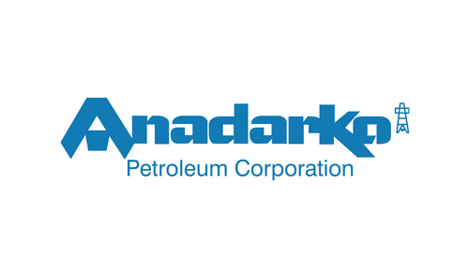**

**GUNNISON EXPORT RISERS FITNESS FOR SERVICE**

**WALL THICKNESS ASSESSMENT**

**NOVEMBER - 2018**

|  |  |  |  |  |  |
| --- | --- | --- | --- | --- | --- |
| **Document Revisions** | | | | | |
| **Rev.** | **Date** | **Description** | **Prepared By** | **Reviewed By** | **Approved By** |
| 01 | 20 Nov 2018 | New document | V. Achanta | V. Shah/ P. Enuganti | D. Gallagher |
|  |  |  |  |  |  |
|  |  |  |  |  |  |

***Prepared for:***

**Anadarko Petroleum Corporation**

**1201 Lake Robbins Drive**

**The Woodlands, Texas 77380**

***Prepared by:***

**Energo Engineering**

**601 Jefferson St.**

**Houston, Texas 77002**

**Energo Engineering Project No.: E18110**

**Energo Engineering Report No.: E18110-01**



***A Registered Texas Engineering Firm No: F-10973***

**REVISION TABLE**

|  |  |  |
| --- | --- | --- |
| **Rev** | **Date** | **Change Description** |
|  |  |  |

Table of Contents

[List of Figures iii](#_Toc530401113)

[List of Tables iv](#_Toc530401114)

[1 Summary 6](#_Toc530401115)

[2 Introduction 6](#_Toc530401116)

[3 Design Data and Analysis Methodology 6](#_Toc530401117)

[3.1 Design Data 6](#_Toc530401118)

[3.2 Minimum Design Wall Thickness 7](#_Toc530401119)

[3.3 Analysis Methodology 7](#_Toc530401120)

[4 Measured Data 9](#_Toc530401121)

[4.1 Oil export 9](#_Toc530401122)

[4.2 Gas Export 12](#_Toc530401123)

[4.3 Measured Data Review 15](#_Toc530401124)

[5 FFS Assessment 16](#_Toc530401125)

[5.1 Oil export, Feature 4 and Feature 3 16](#_Toc530401126)

[5.2 Gas export, Feature 3 19](#_Toc530401127)

[6 REFERENCES 22](#_Toc530401128)

[Appendix A. Minimum Wall Thickness Requirements 23](#_Toc530401129)

[Appendix B. Local Metal Loss, Detailed Methodology and Calculations 24](#_Toc530401130)

[Appendix C. Measured Data Comparison, PEC and UT 27](#_Toc530401131)

# List of Figures

[Figure 5.1 - Oil Export Measured Areas 8](#_Toc530330882)

[Figure 5.2 - Oil Export, Area1 9](#_Toc530330883)

[Figure 5.3 - Oil Export, Area2 9](#_Toc530330884)

[Figure 5.4 - Oil Export, Area3 10](#_Toc530330885)

[Figure 5.5 - Oil Export, Area4 10](#_Toc530330886)

[Figure 5.6 - Gas Export Measured Areas 11](#_Toc530330887)

[Figure 5.7 - Gas Export, Area1 12](#_Toc530330888)

[Figure 5.8 - Gas Export, Area2 12](#_Toc530330889)

[Figure 5.9 - Gas Export, Area3 13](#_Toc530330890)

# List of Tables

[Table 3.1: Design Data 6](#_Toc530330891)

[Table 4.1: Minimum Required Wall Thickness 7](#_Toc530330892)

[Table 5.1 – Oil Export Measured Areas 8](#_Toc530330893)

[Table 5.2 – Gas Export Measured Features 11](#_Toc530330894)

[Table 8.1: Minimum Required Wall Thickness Evaluation 15](#_Toc530330895)

###### **Abbreviations**

APC Anadarko Petroleum Corporation

FFS Fitness for service

FCA Future corrosion allowance, typically in inch

PEC Pulse Eddy Current

UT Ultrasound Thickness

# Summary

TBA

Recommend to:

* Find root cause of corrosion. Implement corrosion mitigation measures (Coatings etc.) accordingly.
* Utilize the current UT readings as baseline and take new measurements (suggest after 1 year period)
* To establish a more certain future corrosion rate and thus more certain life.
* Future measurement frequency can thus be based on condition based monitoring (CBM)

Summary Tables:

Oil Export

|  |  |  |  |  |
| --- | --- | --- | --- | --- |
| **Assessment Area** | **API 579 – Level 1** | | **API 579 – Level 2** | |
| MAWP (psi) | FCA (in) | MAWP (psi) | FCA (in) |
| Feature 4  12” x 16” – Uniform Corr. Rate | 2700 | 0.100 | 2850 | 0.127 |
| Feature 3  6” x 6” – Uniform Corr. Rate | 3100 | 0.150 | 3100 | 0.163 |
| **For Information Only** | | | | |
| Feature 4  12” x 16” – Non-uniform Corr. Rate  **(Use for Info Only)** | 2750 | 0.126 | 2850 | 0.157 |

Gas Export

|  |  |  |  |  |
| --- | --- | --- | --- | --- |
| **Assessment Area** | **API 579 – Level 1** | | **API 579 – Level 2** | |
| MAWP (psi) | FCA (in) | MAWP (psi) | FCA (in) |
| 9” x 4” – Uniform Corr. Rate | 2528 | 0.06 | 2678 | 0.091 |
| 5” x 4” – Uniform Corr. Rate | 2660 | 0.08 | 2680 | 0.095 |
| **For Information Only** | | | | |
| 9” x 4” – Non-uniform Corr. Rate  **(Use for Info Only)** | 2528 | 0.08 | 2678 | 0.120 |

# Introduction

Anadarko Petroleum Company operates the Gunnison field in Gulf of Mexico block GB 668 in water depth of 3150’. During a routine center well ropes access inspection, visible corrosion scale was observed on both the Oil and Gas export riser hull piping below Spar deck. Wall thickness at areas of observed corrosion has been measured by CAN-USA ropes access personnel through Pulse Eddy Current (PEC) and subsequently grid Ultrasonic Testing (UT).

Energo Engineering (Energo) has performed Engineering assessment based on measured wall thickness data to assess the Fitness for Service (FFS) of the riser piping for continued operations.

# Basis for FFS Assessment and Analysis Methodology

## Design Data

The design data for oil and gas export riser hull piping is given in Table 3.1 [5]. The elevation drawing for the piping below Spar deck is provided in Figure 3.1. The Spar deck elevation is 50’ above Mean Water Level (MWL). The bottom 33’ of piping below Spar deck until the top support has Splashtron coating and top 17’ of piping is coated with FBE.

|  |  |  |  |
| --- | --- | --- | --- |
| **Description** | **Units** | **Oil Riser Piping** | **Gas Riser Piping** |
| **Design Code** | n/a | ASME B31.4 | ASME B31.8 |
| **Outer Diameter, OD** | Inch | 18.0 | 16.0 |
| **Material Grade** | n/a | X-60 | X-65 |
| **Material Yield Strength, [1]** | Psi | 60,200 | 65,300 |
| **Maximum Allowable Operating Pressure, MAOP** | Psi | 2220 | 2220 |
| **Operating Pressures (psi)**  **(on 10-25-2018)** | Psi | 315 | 1245 |
| **Maximum Operating Temperature** | ˚F | 82 | 90 |
| **Ambient Temperature** | ˚F | 50 | 50 |
| **Nominal Wall Thickness, tnom** | Inch | 0.750 | 0.625 |
| **Operating Period (2004 to 2018)** | Years | 15 | 15 |

Table .: Design Data

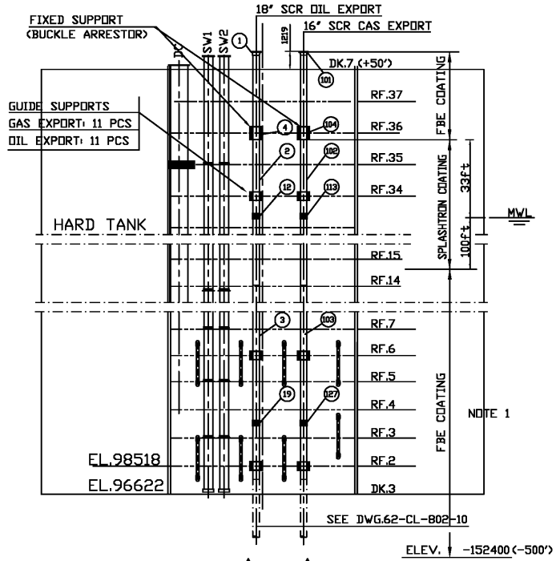

Figure 3.1 –Gunnison Export Riser Hull Piping

## Minimum Design Wall Thickness

The minimum wall thickness required is calculated using design data in Section 3.1 and corresponding design code.

* The minimum wall thickness required per design code at Maximum Allowable Operating Pressure (MAOP) is summarized below and listed in Table 3.2:
  + Oil export piping is 0.538”
  + Gas export piping is 0.526”
* The required minimum wall thickness per design check:
  + Is driven by internal pressure
  + Does not take into account the manufacturing tolerance, ovality etc.
  + A more detailed wall thickness sizing is provided in Appendix A.

|  |  |  |  |
| --- | --- | --- | --- |
| **Description** | **Units** | **Oil Riser Piping** | **Gas Riser Piping** |
| **Design Code** | n/a | ASME B31.4 | ASME B31.8 |
| **Governing Condition** | n/a | Internal Pressure | Internal Pressure |
| **Design Factor, Fd** | n/a | 0.60 | 0.50 |
| **Maximum Allowable Operating Pressure, MAOP** | psi | 2220 | 2220 |
| **Minimum Wall Thickness, tmin** | Inch | **0.538** | **0.526** |

Table .: Minimum Required Wall Thickness per Design Code Check

## Analysis Methodology

To determine if the export riser piping is fit for service and to calculate Future Corrosion Allowance (FCA) at the locations of observed corrosion, two approaches were evaluated as per API 579-1/ ASME FFS-1 2016- General Metal Loss (GML) and Local Metal Loss (LML). GML is less conservative than LML, assumes smooth cross sections and uses an average thickness approach. Based on the UT results and wall thickness profiles along certain areas of circumference, LML was also analyzed. LML considers the area at and around the lowest measured wall thickness to determine a flaw profile. An allowable Future Corrosion Allowance (FCA) is calculated using LML.

The fitness-for-service analysis methodology used for the export riser piping assessment is described below:

Screening of measured wall thickness profiles:

* + Following screening, it is determined that further assessment is required
  + Typical assessments for metal loss are:
    - General metal loss (General corrosion, uniform corrosion)
    - Local metal loss (metal loss close to tmin or more in local areas, grooves etc.)
    - Pitting corrosion
* If general metal loss is identified:
  + Ensure that there are no local stress concentrations or hot spots
  + Perform Level 1 analysis
  + If level 1 is unacceptable, adjust FCA or perform level 2
  + If level 2 is unacceptable, adjust FCA or perform level 3
* If local metal loss is identified:
  + Determine if it is local thin area (LTA) flaw or groove-like flaws
  + Perform Level 1 analysis for either or both as required.
  + If level 1 is unacceptable, adjust FCA or perform level 2
  + If level 2 is unacceptable, adjust FCA or perform level 3
* Acceptance criteria is as follows:
  + The remaining life is acceptable assuming an expected future corrosion rate(or)
  + The future corrosion allowance for remaining life is acceptable for the maximum allowable working pressure.
* A high level analysis methodology is shown in Figure 3.1.



Figure . –High Level FFS Analysis Methodology

# Measured Data

The measured data for the Gunnison oil and gas export piping is described in this section. The following measured thickness data are obtained for the export risers:

* Initial Pulse Eddy Current (PEC) data, which has an accuracy of 20%, is used for screening purposes
* Ultrasonic Thickness (UT) data obtained by using the ultrasonic probe are accurate to within 0.001”. Local metal loss FFS assessment was performed based on UT data.

The UT wall thickness profile summary along with contour plots are shown below. A comparison between UT and PEC data is shown in Appendix D.

## Oil Export Riser Piping

The summary measured wall thickness data for the oil export riser are provided in Table 4.1 and shown in Figure 4.1, [3]. The contour plots for the measured wall thickness areas are also given in this section.

|  |  |  |  |  |
| --- | --- | --- | --- | --- |
| **OE Feature ID#** | **Distance below Spar Deck** | **Contour Reference** | **Min Measured WT** | **Avg Measured WT** |
| 1 | 1’ | Figure 4.5 | 0.536 | 0.694 |
| 2 | 3’ 6” | Figure 4.4 | 0.580 | 0.687 |
| 3 | 6’ 2” | Figure 4.3 | 0.630 | 0.695 |
| 4 | 9’ 6” | Figure 4.2 | 0.668 | 0.736 |

Table . – Oil Export Piping - Measured UT Wall Thickness Measurements

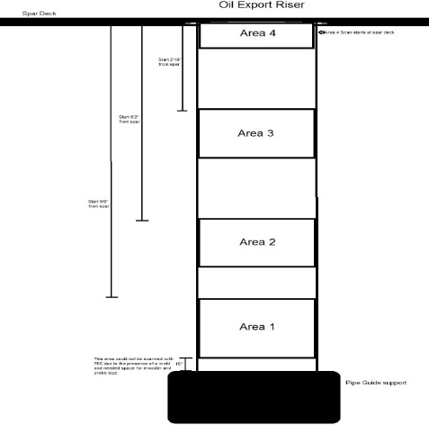

Figure . - Oil Export – Observed Locations of Corrosion

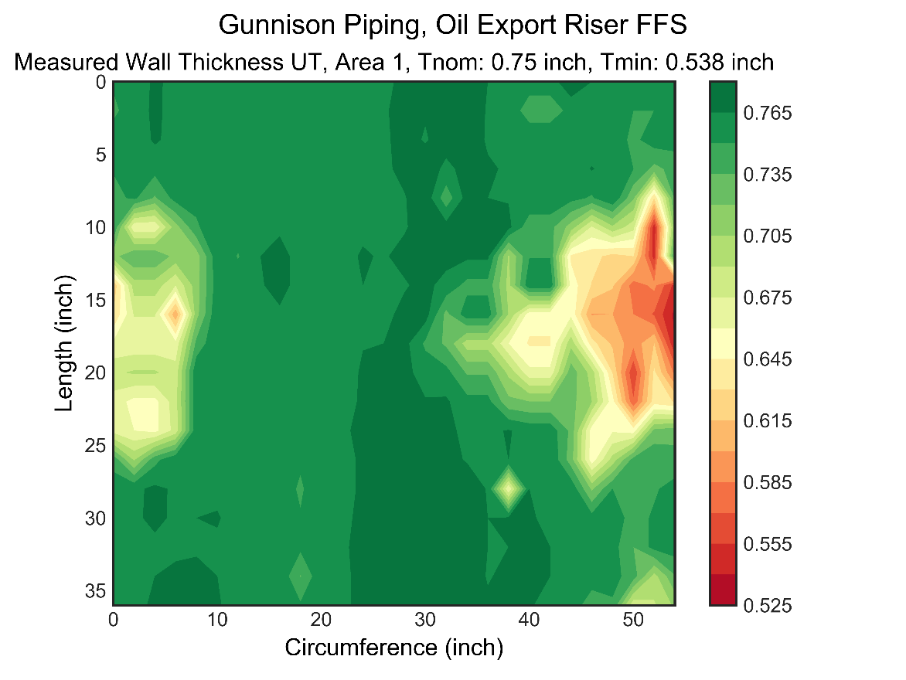

Figure . - Oil Export, Area1

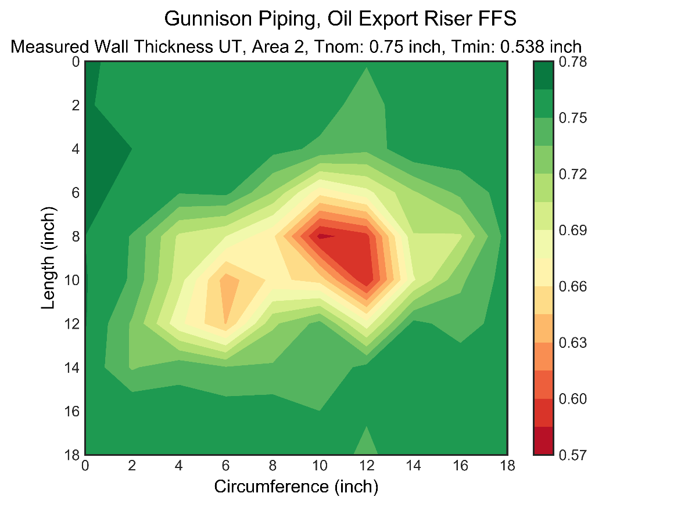

Figure . - Oil Export, Area2

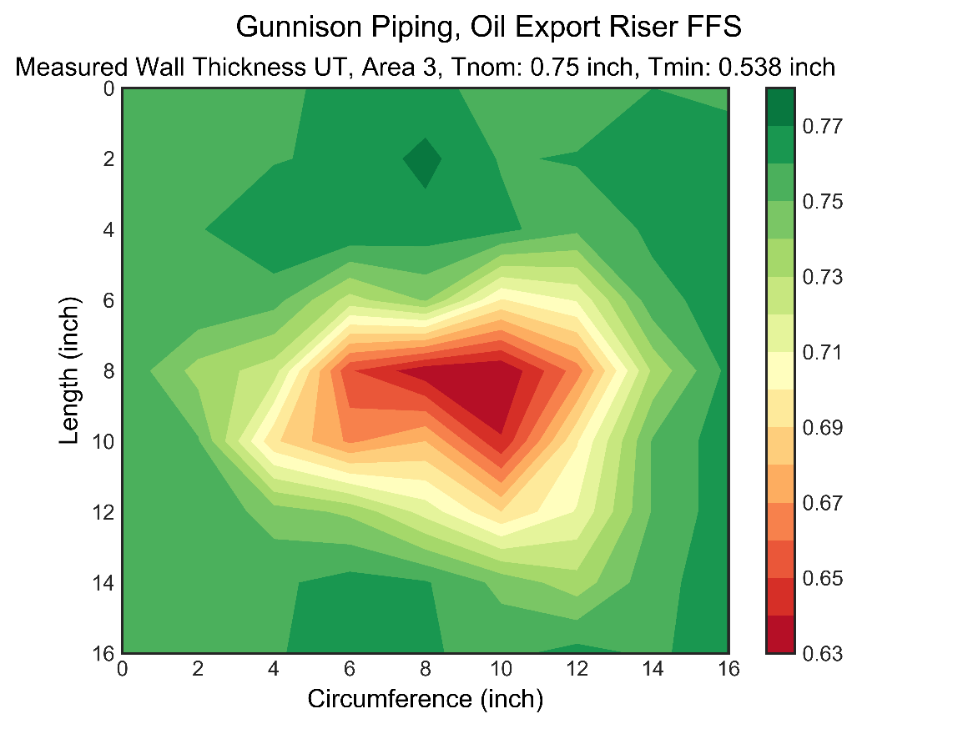

Figure . - Oil Export, Area3

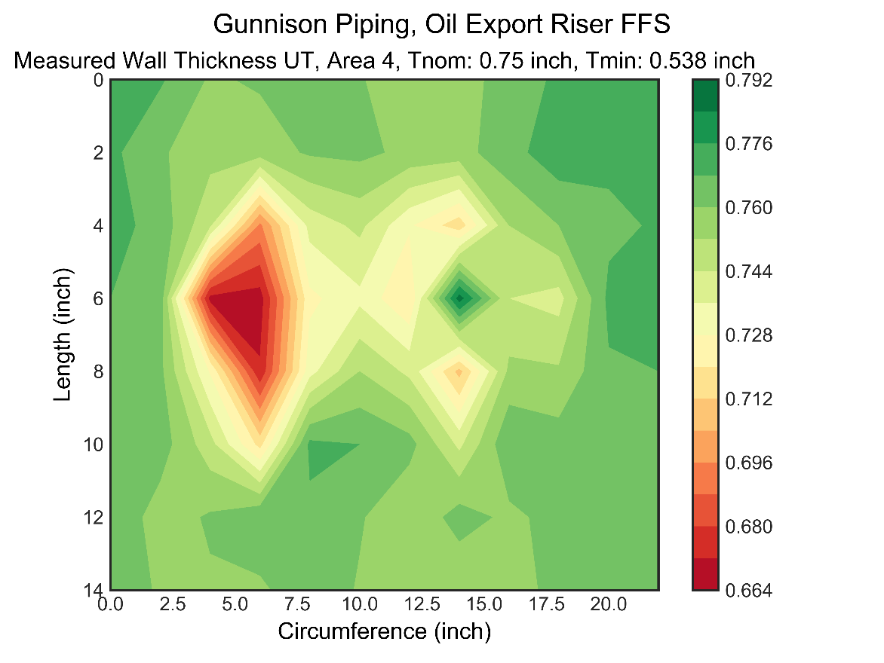

Figure . - Oil Export, Area4

## Gas Export

The measured wall thickness locations for the gas export riser are given in Table 4.2 and shown in Figure 4.6, Reference 4. The contour plots for the areas are given in ???

|  |  |  |  |  |  |  |
| --- | --- | --- | --- | --- | --- | --- |
| **GE ID#** | **Distance below Spar Deck** | **Area ID#,** | **Feature ID#** | **Contour Reference** | **Min Measured WT** | **Avg Measured WT** |
| 1 | 8’ | 1 | 1 | Figure 4.7 | 0.565 | 0.611 |
| 2 | 5’ 7” | 2 | 2 | Figure 4.8 | 0.560 | 0.623 |
| 3 | 10’ 3” | 3 | 3 | Figure 4.9 | 0.488 | 0.626 |

Table . – Gas Export Measured Features

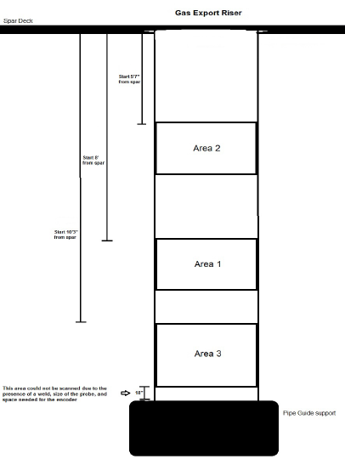

Figure . - Gas Export Measured Areas

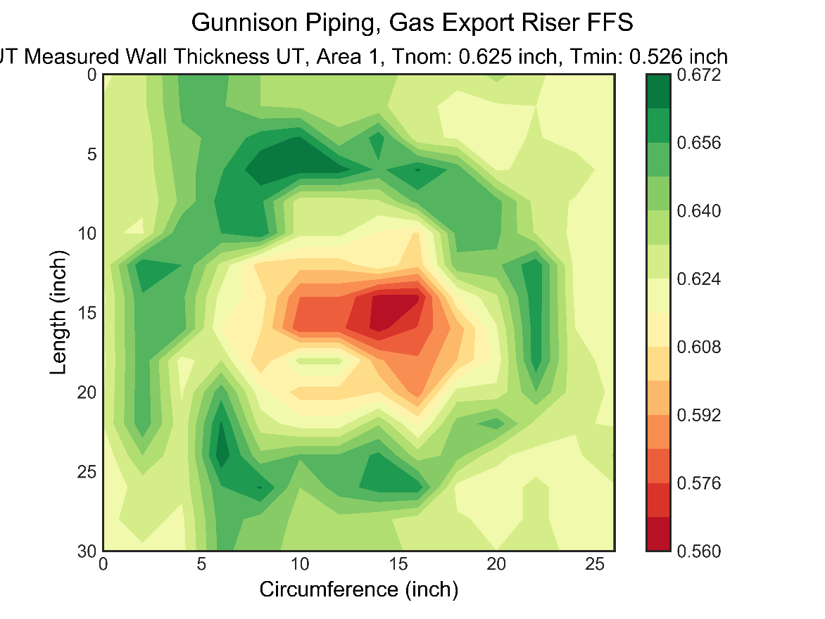

Figure . - Gas Export, Area1

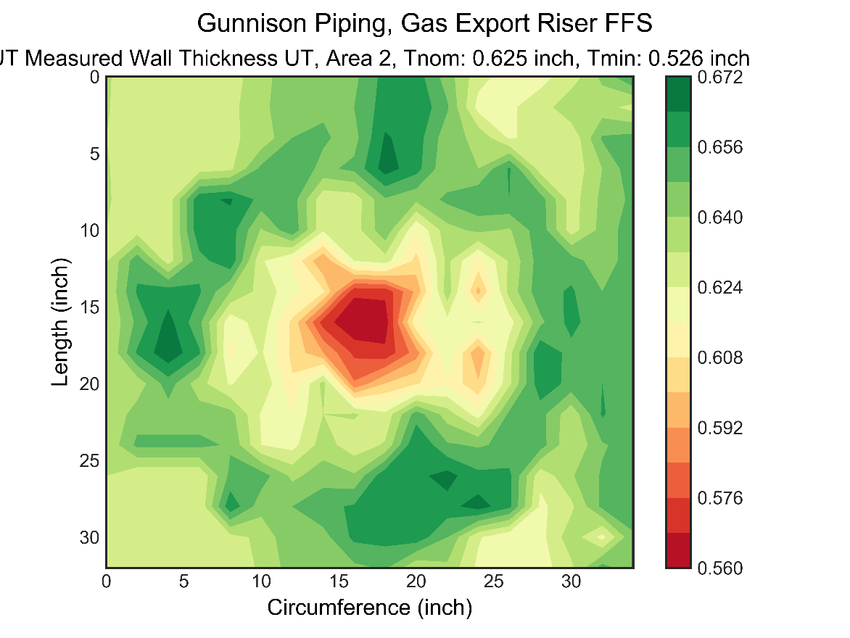

Figure . - Gas Export, Area2

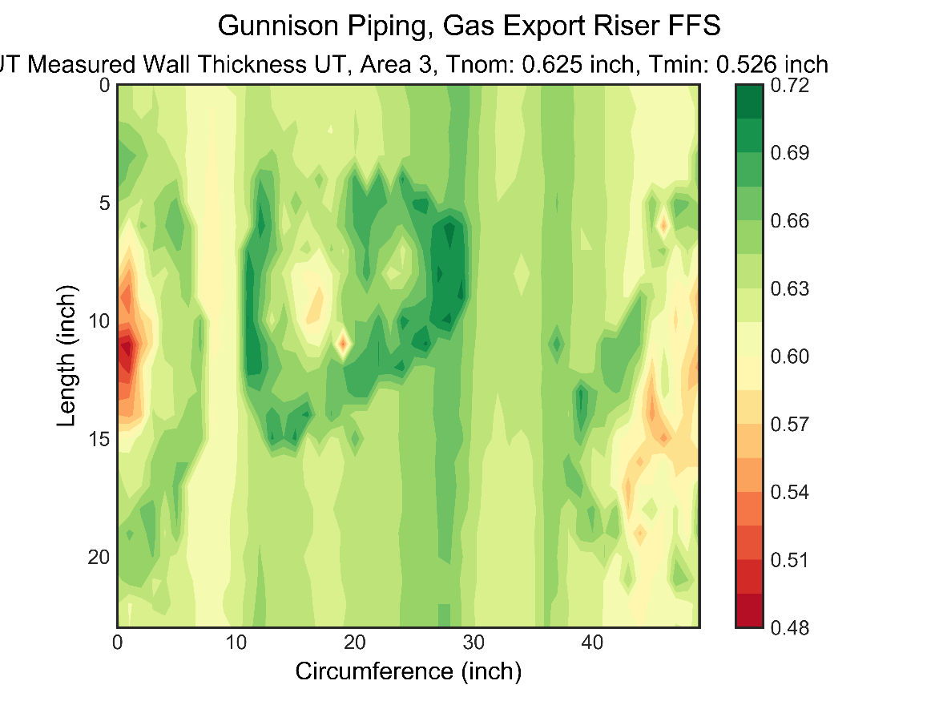

Figure . - Gas Export, Area3

## Measured Data Review

Measured data is reviewed to determine the fitness for service methodology to be used for analysis. Based on the review of the wall thickness measurements and contour plots in sections 4.1 and 4.2, the following conclusions and further analysis are required:

* Based on the preliminary WT thickness data, the average measured wall thickness was significantly higher than the minimum wall thickness (Tmin)
* Due to presence of large general corrosion areas, local metal loss was identified to be required.
* Local metal loss analysis is performed using the API 579 fitness for service code, Reference 2.
* The following areas are selected for FFS analysis based on the measured wall thickness:
  + Oil export, Feature 3 and Feature 4 based on minimum measured wall thickness and average wall thickness.
  + Gas export, Feature 3 based on multiple measurement data points below Tmin.

# FFS Assessment Results

Local Metal Analysis is performed to determine the future corrosion allowance for the continued future operations. The analysis is performed for oil and gas export risers for the following features:

* Oil export, Feature 3 and Feature 4
* Gas export, Feature 3

## Oil Export Piping Feature 3 and Feature 4

Based on API FFS Level 2 Assessment for oil export piping, the maximum allowable FCA is calculated based two approaches:

Case 1 (Assuming uniform corrosion rate across the entire feature):

* Maximum Allowable Working Pressure (MAWP) due to presence of flaw profile (MAWP 2,850 psi > MAOP 2,220 psi)
* Flaw size 12” x 16”: Allowable FCA is 0.127” for MAOP of 2,220 psi

Case 2 (Assuming non-uniform corrosion rate across the entire feature):

* Maximum Allowable Working Pressure (MAWP) due to presence of flaw profile (MAWP 2,850 psi > MAOP 2,220 psi)
* Corrosion Rate away from flaw = 0.25 \* Corrosion Rate at the flaw
* Flaw size 12” x 16”: Allowable FCA is 0.157” for MAOP of 2,220 psi
* 0.157 inch at the flaw area assuming the FCA (rate) away from the flaw is 0.04 inch (0.25\* FCAflaw or rate) for feature 4
* 0.127 inches at flaw area assuming uniform future corrosion (rate) at both flaw and away from flaw for feature 4
* 0.163 inches at flaw area assuming uniform future corrosion (rate) at both flaw and away from flaw for feature 3
* A life from FCA can be established with an assumed future corrosion rate

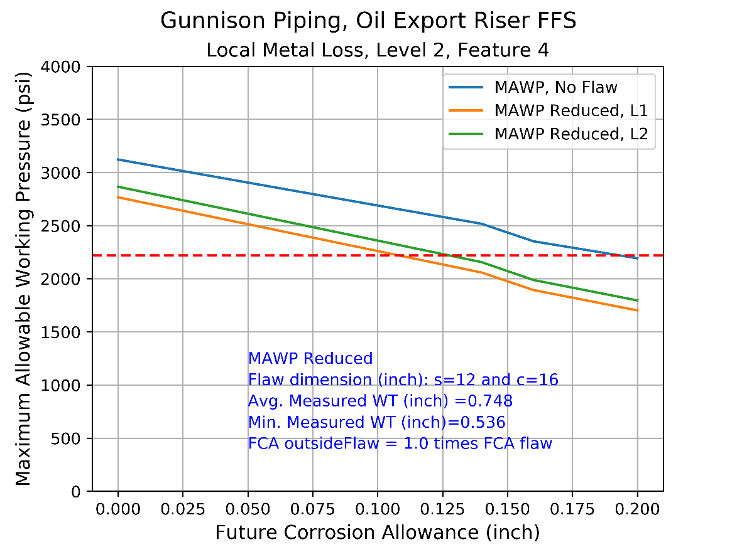

Figure . – MAWP with FCA, Feature 4, FCAoutsideflaw = 1.00 \* FCAFlaw.

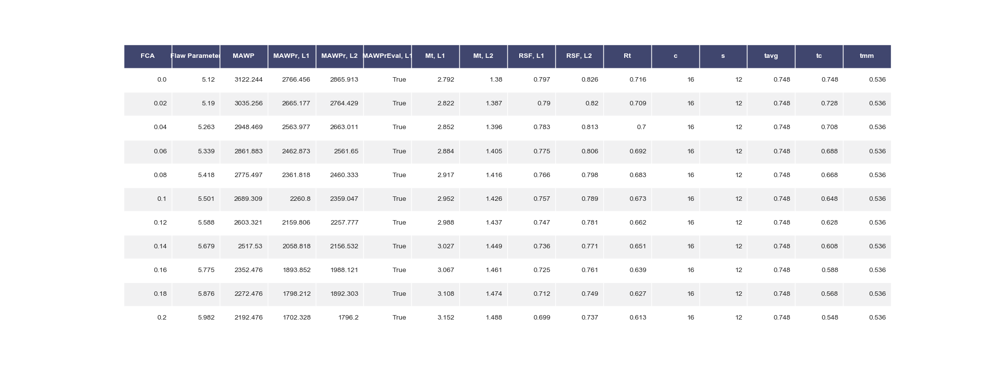

Table . – Detailed Results, Feature 4, FCAoutsideflaw = 1.00 \* FCAFlaw.

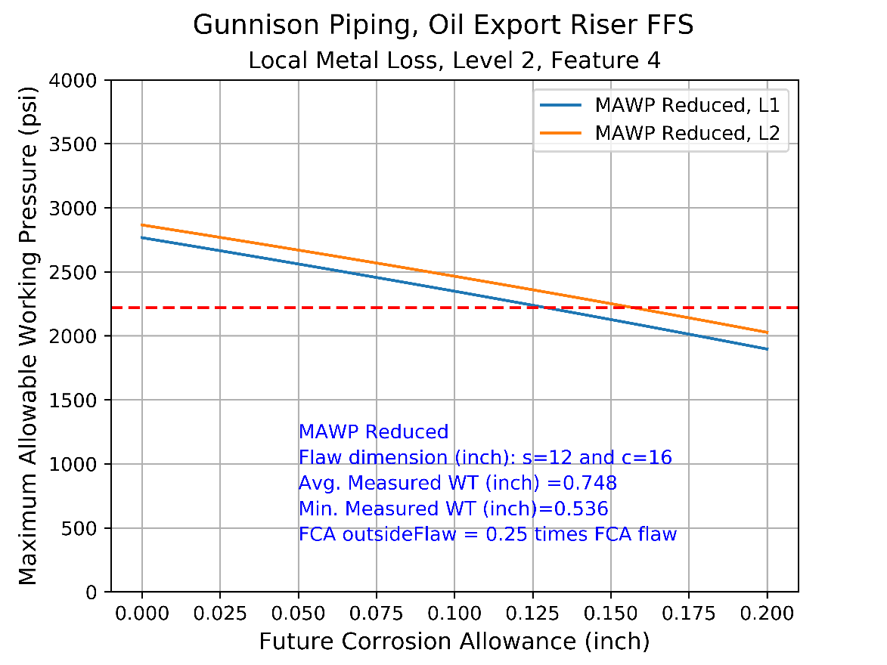

Figure . – MAWP with FCA, Feature 4, FCAoutsideflaw = 0.25 \* FCAFlaw

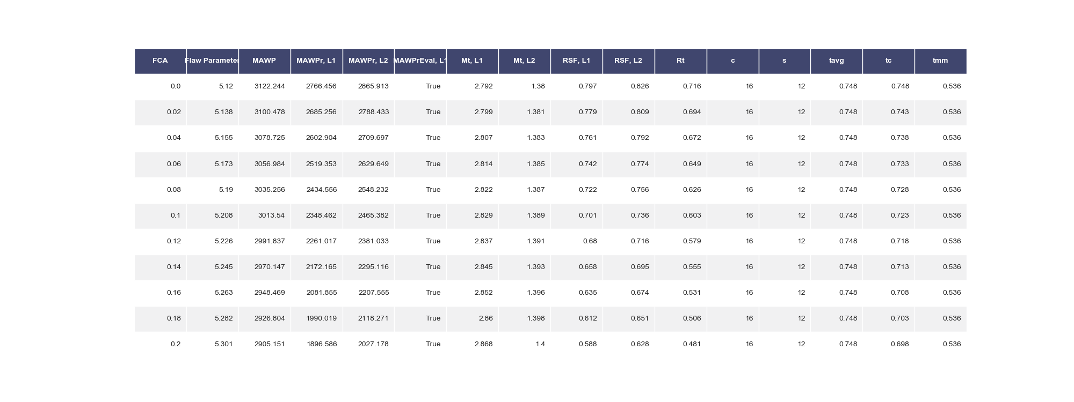

Table . – Detailed Results, Feature 4, FCAoutsideflaw = 0.25 \* FCAFlaw.

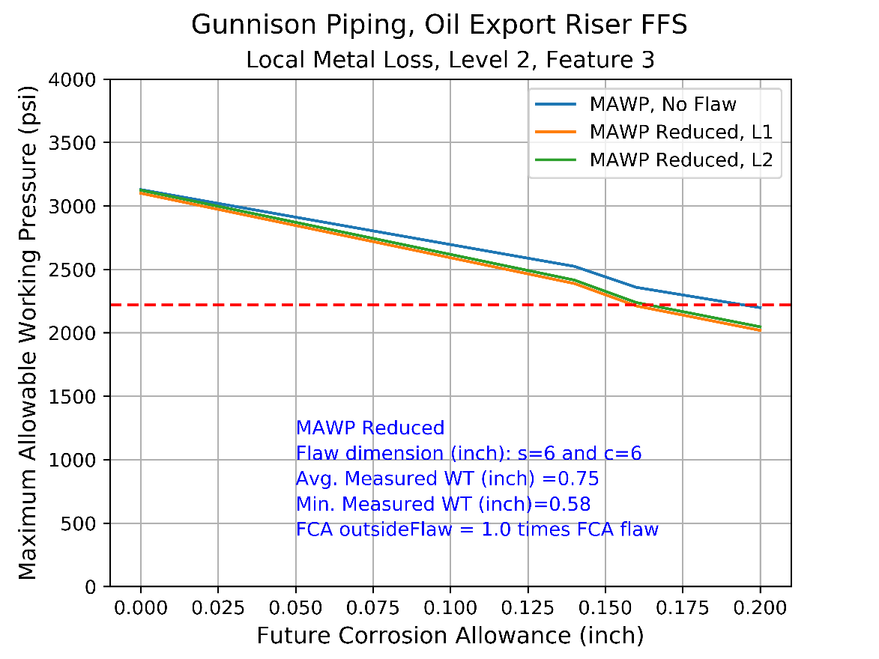

Figure . – MAWP with FCA, Feature 3, FCAoutsideflaw = 1.00 \* FCAFlaw.

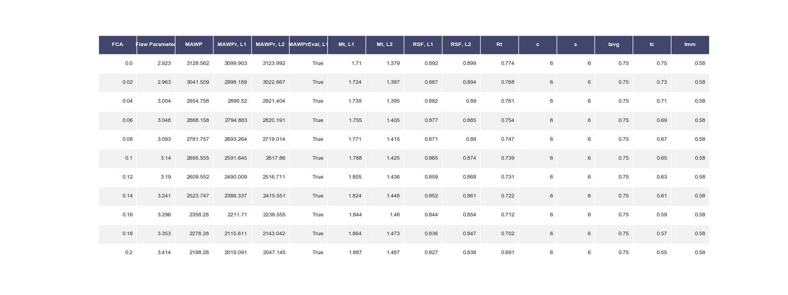

Table . – Detailed Results, Feature 3, FCAoutsideflaw = 1.00 \* FCAFlaw.

## Gas export, Feature 3

Based on level 2 assessment for gas export area 3, the maximum allowable FCA is:

* 0.120 inch at the flaw area assuming the FCA (rate) away from the flaw is 0.03 inch (0.25\* FCAflaw or rate)
  + An example detailed local metal loss analysis for this feature for a single future corrosion allowance (FCA) assumption is given in Appendix C.
* 0.091 inches assuming uniform future corrosion (rate) at both flaw and away from flaw.
* A life from FCA can be established with an assumed future corrosion rate

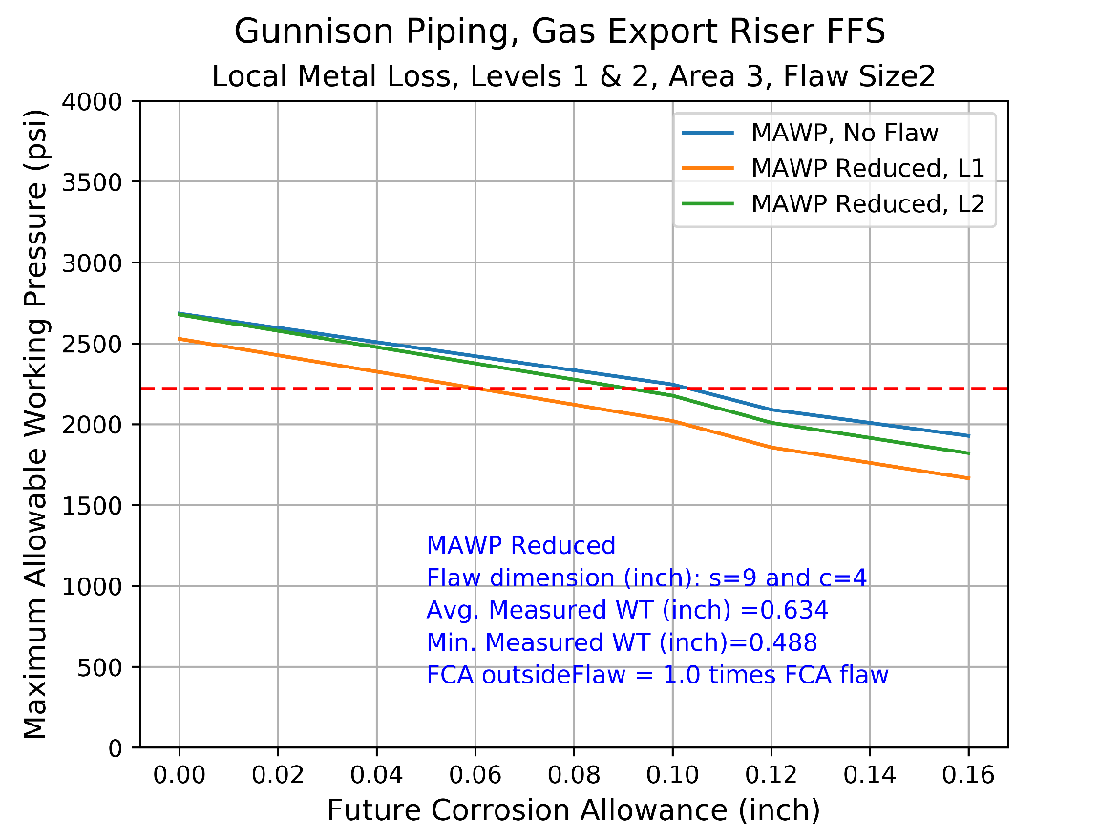

Figure . – MAWP with FCA, Feature 3, FCAoutsideflaw = 1.00 \* FCAFlaw

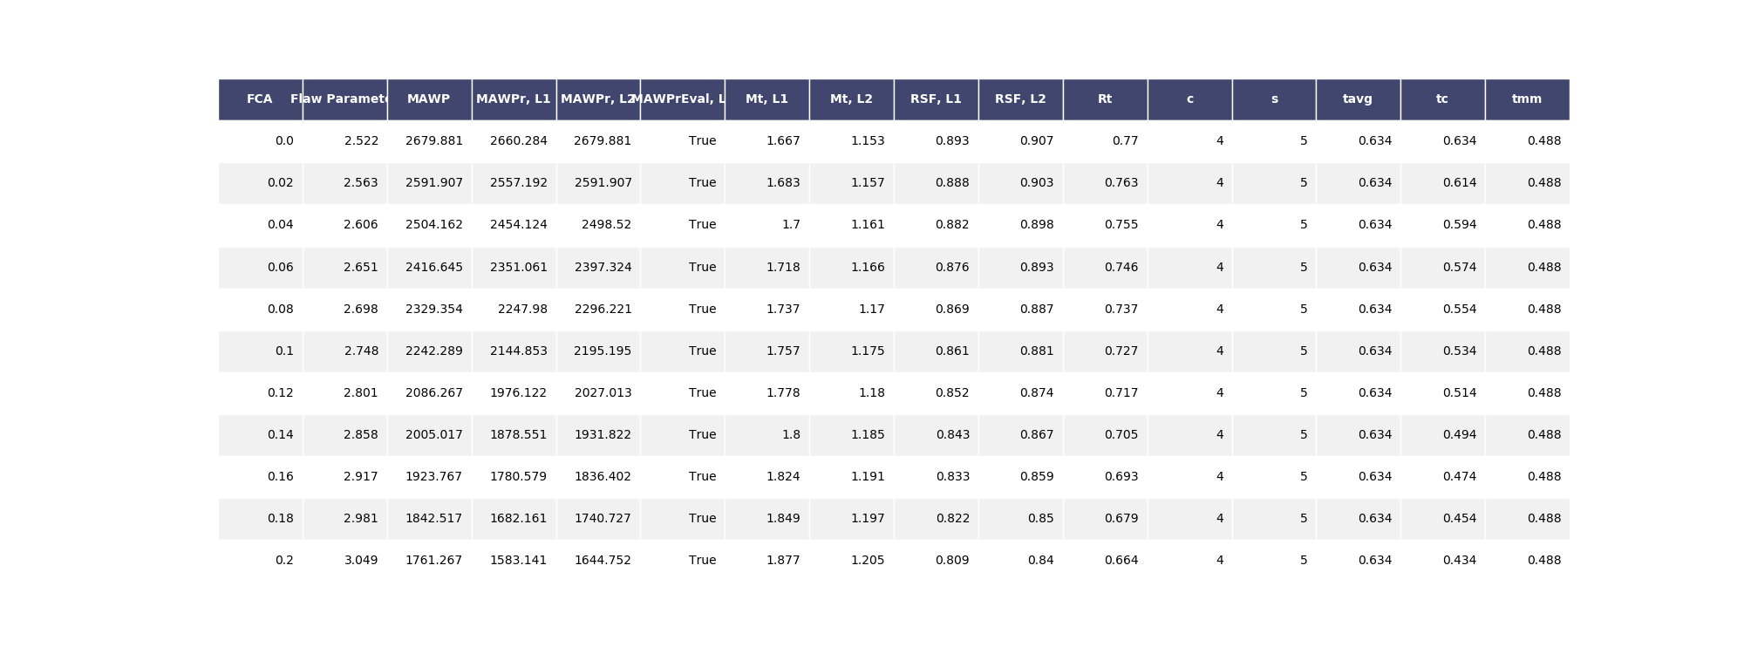

Table . – Detailed Results, Feature 3, FCAoutsideflaw = 1.00 \* FCAFlaw.

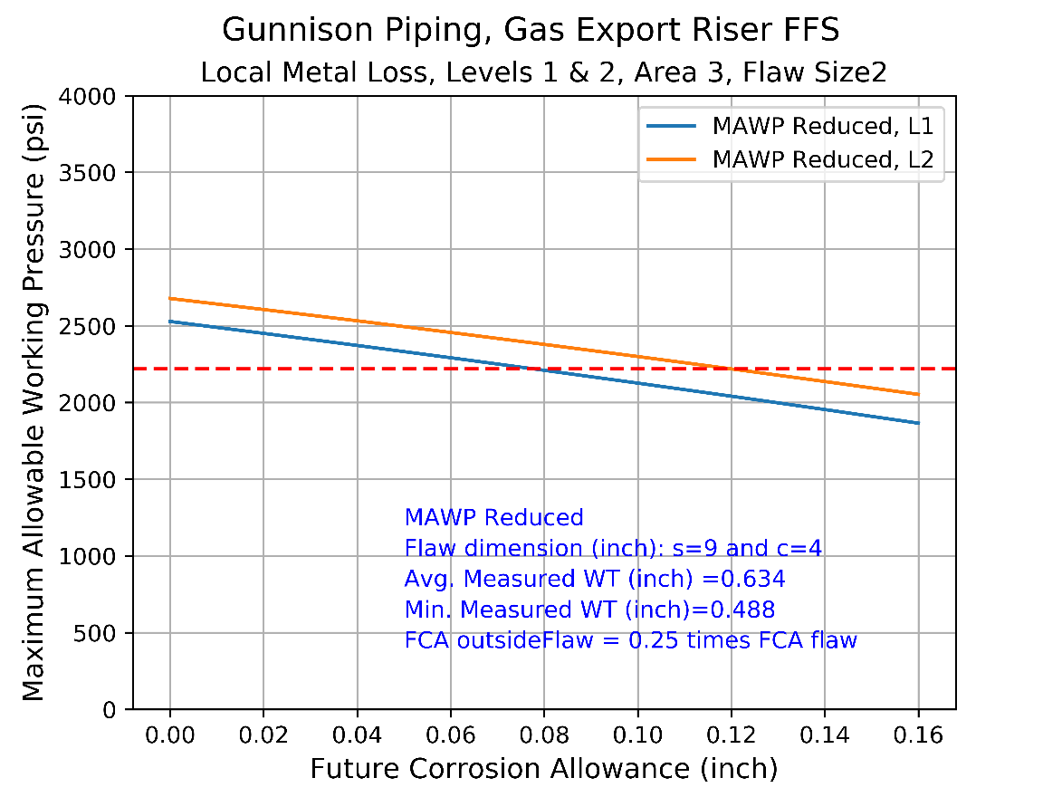

Figure . – MAWP with FCA, Feature 3, FCAoutsideflaw = 0.25 \* FCAFlaw

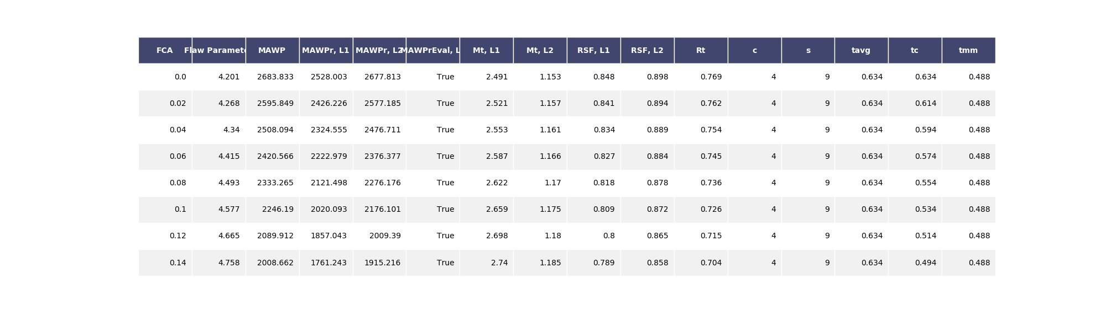

Table . – Detailed Results, Feature 3, FCAoutsideflaw = 0.25 \* FCAFlaw.

# Conclusions and Recommendations

Add –

Conclusions:

Results based on current measured wall thickness profile following a API 589 Level II assessment,

* Oil Export Maximum Allowable Working Pressure (MAWP) is 2,850 psi which is higher than design MAOP of 2,220 psi
* Gas Export Maximum Allowable Working Pressure (MAWP) is 2,678 psi which is higher than design MAOP of 2,220 psi

Local metal loss approach

* Oil Export Allowable FCA = 0.13 inch based on local thinning area of Area 4 (Lvl 2 Assessment)
* Gas Export Allowable FCA = 0.09 inch based on local thinning area of Area 3 (Lvl 2 Assessment)

Recommendations:

* Reinstate coating immediately to arrest corrosion and obtain post-coating remediation visual feedback
* Based on coating quality recommend 6 monthly UT grid readings for critical regions – Oil Export features 3 and 4; Gas Export feature 3
* Inspection frequency may be increased to 12 months after corrosion rates are established and trended

# REFERENCES

1. American Petroleum Institute, “Specification for Line Pipe”, API SPEC 5L, October 2007
2. American Petroleum Institute, “Fitness-For-Service”, API 579-1/ASME FFS-1, June 2016
3. CAN, “UT (UTT) Examination of Oil Export Riser, Gunnison Area Center Well”, 5 November 2018
4. CAN, “UT (UTT) Examination of Gas Export Riser, Gunnison Area Center Well”, 7 November 2018
5. Kerr McGee Oil and Gas Corporation, “Gunnison Project – Piping Lay-out, Export Risers Hard Tank”, 62-CL-802-01, Rev AB, 16 January 2002.

,

1. Minimum Wall Thickness Requirements

The minimum wall thickness required based on design code is evaluated for the following:

* Hoop stress driven by Internal pressure
* Equivalent stress driven by all stress components

The minimum wall thickness required and the design code parameters used for the evaluation are given in Table 6.1.

|  |  |  |  |
| --- | --- | --- | --- |
| **Description** | **Units** | **Oil Riser Piping** | **Gas Riser Piping** |
| **Design Code** | n/a | ASME B31.4 | ASME B31.8 |
| **Temperature Derating** | n/a | None | None |
| **Internal Pressure (Governing Condition)** | | | |
| **Design Factor, Fd** | n/a | 0.60 | 0.50 |
| **Maximum Allowable Operating Pressure, MAOP** | psi | 2220 | 2220 |
| **Minimum Wall Thickness, tmin** | Inch | **0.538** | **0.526** |
| **All Loads – Equivalent Stress** | | | |
| **Design Factor, Fd** | n/a | 0.90 | 0.90 |
| **Maximum Allowable Operating Pressure, MAOP** | psi | 2220 | 2220 |
| **Maximum Operating Temperature** | ˚F | 82 | 90 |
| **Ambient Temperature** | ˚F | 50 | 50 |
| **Minimum Wall Thickness, tmin** | Inch | **0.417** | **0.337** |

Table .: Minimum Required Wall Thickness Evaluation

1. Local Metal Loss, Detailed Methodology and Calculations

A detailed calculation for local metal loss is provided in this section. The detailed calculation is for:

* Gas export riser
* Feature 3
* FCAoutsideflaw = 0.25 \* FCAFlaw.

|  |  |  |
| --- | --- | --- |
| **Calculation** | **Value** | **Comments, Reference 2** |
|  |  | Get Wall thickness readings.  API 579,  LML Level 1, Section XX |
|  | 0.634 inch | Get uniform thickness away from local metal loss  API 579,  LML Level 1, Section XX |
|  | Check | Defines the measurement interval  API 579,  LML Level 1, Section XX |
|  | LTA, No grooves | Determine if local thin area or groove type of local flaw |
|  | FCA = 0.025 inch  FCAml=0.100 inch  tc = 0.609 inch |  |
|  | Tmm = 0.488 inch  s = 9 inch  c = 4 inch |  |
|  | Rt = 0.637  Lambda = 4.286 |  |
|  | True  True |  |
|  | Not required |  |
|  |  |  |
|  | RSF = 0.743  RSFa = 0.90  MAWPR = RSF/RSFa \* MAWP |  |
| **For Level 2** |  |  |
| TBA |  |  |

1. Comparison of PEC and UT Data

The following measured thickness data are given in this section:

* Pulse Eddy Current (PEC) data obtained by using the pulse eddy current tool
* Ultrasonic Thickness (UT) data obtained by using the ultrasonic gauge/

The UT measurements are known to be more accurate than PEC measurements.

**Oil Export, UT vs. PEC**

|  |  |
| --- | --- |
| C:\Users\vamsee.achanta\Dropbox\Engineering\0176 KBR FFS Analysis\COD\API579\results\Plots\Ut grid area 1 oil export_UT, Area 1_Contour.png | C:\Users\vamsee.achanta\Dropbox\Engineering\0176 KBR FFS Analysis\COD\API579\results\Plots\PEC Oil Export_PEC, Area 1_Contour.png |
| C:\Users\vamsee.achanta\Dropbox\Engineering\0176 KBR FFS Analysis\COD\API579\results\Plots\Ut grid area 2 oil export_UT, Area 2_Contour.png | C:\Users\vamsee.achanta\Dropbox\Engineering\0176 KBR FFS Analysis\COD\API579\results\Plots\PEC Oil Export_PEC, Area 2_Contour.png |
| C:\Users\vamsee.achanta\Dropbox\Engineering\0176 KBR FFS Analysis\COD\API579\results\Plots\Ut grid area 3 oil export_UT, Area 3_Contour.png | C:\Users\vamsee.achanta\Dropbox\Engineering\0176 KBR FFS Analysis\COD\API579\results\Plots\PEC Oil Export_PEC, Area 3_Contour.png |
| C:\Users\vamsee.achanta\Dropbox\Engineering\0176 KBR FFS Analysis\COD\API579\results\Plots\Ut grid area 4 oil export_UT, Area 4_Contour.png | C:\Users\vamsee.achanta\Dropbox\Engineering\0176 KBR FFS Analysis\COD\API579\results\Plots\PEC Oil Export_PEC, Area 4_Contour.png |

**Gas Export, UT vs. PEC**

|  |  |
| --- | --- |
| C:\Users\vamsee.achanta\Dropbox\Engineering\0176 KBR FFS Analysis\COD\API579\results\Plots\Gas export area 1 grid_UT_UT, Area 1_Contour.png | C:\Users\vamsee.achanta\Dropbox\Engineering\0176 KBR FFS Analysis\COD\API579\results\Plots\PEC Oil Export_PEC, Area 4_Contour.png |
| C:\Users\vamsee.achanta\Dropbox\Engineering\0176 KBR FFS Analysis\COD\API579\results\Plots\Gas export area 2 grid_UT_UT, Area 2_Contour.png | C:\Users\vamsee.achanta\Dropbox\Engineering\0176 KBR FFS Analysis\COD\API579\results\Plots\PEC Gas Export Below Spar_PEC, Area 2_Contour.png |
| C:\Users\vamsee.achanta\Dropbox\Engineering\0176 KBR FFS Analysis\COD\API579\results\Plots\gas export area 3 grid_UT_UT, Area 3_Contour.png | C:\Users\vamsee.achanta\Dropbox\Engineering\0176 KBR FFS Analysis\COD\API579\results\Plots\PEC Gas Export Below Spar_PEC, Area 3_Contour.png |